

Zentity (Version 2.0)

Installation Instructions

# Contents

Contents 2

Introduction 4

Set Up Your Environment 4

Installing Visual Studio 2010 4

Installing Microsoft Silverlight 4 SDK 4

Installing Microsoft Silverlight 4 Tools for Visual Studio 2010 4

Installing Microsoft Silverlight PivotViewer 5

Installing Microsoft Expression Blend Software Development Kit (SDK) for Silverlight 4 5

Installing Microsoft Deep Zoom tools 1.0 5

Installing Microsoft Windows SDK for Windows 7 and .NET Framework 4 5

Installing Microsoft SQL Server 2008 R2 Express edition 5

Installing PowerShell 2.0 SDK 5

Installing Enterprise Library 5.0 6

Installing WiX 3.5 6

Download GuanxiMap controls 6

Install Zentity 6

Getting Source Code 6

Pre-Build operations 6

Build the Zentity solution 7

Build the Zentity installers (msi) 8

Conclusion 9

***Disclaimer****: This document is provided “as-is”. Information and views expressed in this document, including URL and other Internet Web site references, may change without notice. You bear the risk of using it.*

*This document does not provide you with any legal rights to any intellectual property in any Microsoft product. You may copy and use this document for your internal, reference purposes.*

*© 2010 Microsoft Corporation. All rights reserved.*

*Microsoft, MSDN, Silverlight, Visual Studio, and Windows are trademarks of the Microsoft group of companies.  All other trademarks are property of their respective owners.*

# Introduction

This document will help in:

* Install the necessary tools.
* Create and configure your development environment.
* Build the solution
* Create Zentity Setup

We will cover all these steps in the following sections.

# Set Up Your Environment

The source code project of Zentity uses Visual Studio 2010 for the development process.

Visual Studio 2010 includes most of the needed desktop development tools within an Integrated Development Environment (IDE). This includes tools such as program editors, compilers, linkers, and debuggers. This is a retail product from Microsoft that runs on top of Windows, and can be obtained for free if you are in Academia via the [DreamSpark](https://www.dreamspark.com/) program.

## Installing Visual Studio 2010

You should already have a system that you can logon, can obtain administrative rights to, and the ‘normal’ software installed, e.g. **Windows, Internet Explorer, Microsoft Office**.

To install Visual Studio 2010

1. Obtain the Visual Studio 2010 setup files and start the installation.
2. Install Visual Studio 2010 with .Net Framework 4.0. You may follow the installation guide at “<http://msdn.microsoft.com/en-us/library/e2h7fzkw.aspx>”.

## Installing Microsoft Silverlight 4 SDK

Download and install Silverlight 4.0 SDK from the following location:

<http://www.microsoft.com/downloads/en/details.aspx?FamilyID=298170d6-567c-4b90-9917-490ffcddba87>

## Installing Microsoft Silverlight 4 Tools for Visual Studio 2010

Download and install Microsoft Silverlight 4 tools for Visual Studio 2010 from the following location:

<http://www.microsoft.com/downloads/en/details.aspx?FamilyID=b3deb194-ca86-4fb6-a716-b67c2604a139>

## Installing Microsoft Silverlight PivotViewer

Download and install Silverlight PivotViewer 1.01 from the following location:

<http://www.microsoft.com/downloads/en/details.aspx?displaylang=en&FamilyID=9a1bb862-d80c-4145-9320-b279a63bff91>

## Installing Microsoft Expression Blend Software Development Kit (SDK) for Silverlight 4

Download and install Expression Blend Software Development Kit (SDK) for Silverlight 4 from the following location:

<http://www.microsoft.com/downloads/en/details.aspx?FamilyID=d197f51a-de07-4edf-9cba-1f1b4a22110d>

## Installing Microsoft Deep Zoom tools 1.0

Download Deep Zoom tools 1.0 from the following location:

<http://www.silverlight.net/learn/whitepapers/download-deep-zoom-tools/>

## Installing Microsoft Windows SDK for Windows 7 and .NET Framework 4

Download and install Microsoft SDK 7 from the following location:

<http://www.microsoft.com/downloads/en/details.aspx?FamilyID=6b6c21d2-2006-4afa-9702-529fa782d63b&displaylang=en>

## Installing Microsoft SQL Server 2008 R2 Express edition

Install SQL Server Enterprise Express edition with Advanced Services from the following location:

<http://www.microsoft.com/express/Database/Default.aspx>

NOTE: To use Change Data Capture (CDC) feature you would need SQL Server Enterprise Edition.

## Installing PowerShell 2.0 SDK

Download and install PowerShell 2.0 SDK from the following location:

<http://www.microsoft.com/downloads/en/details.aspx?FamilyID=50633A1F-A665-425D-923C-1A269F8AC084&displaylang=en>

## Installing Enterprise Library 5.0

Download and install Microsoft Enterprise Library 5.0 from the following location: <http://www.microsoft.com/downloads/details.aspx?familyid=BCB166F7-DD16-448B-A152-9845760D9B4C&displaylang=en>

## Installing WiX 3.5

Download and install wix35.msi from the following location:

[http:/wix.sourceforge.net/releases/3.5.2430.0/](http://wix.sourceforge.net/releases/3.5.2430.0/)

## Download GuanxiMap controls

Download the GuanxiMap controls from Microsoft Research site. This is required for building the source code:

<http://research.microsoft.com/zentity>

## Install Zentity

Download Zentity Server Installer “**Zentity.Installer.Server.msi**” from the following location:

<http://research.microsoft.com/en-us/projects/zentity/>

Download Zentity Client Installer “**Zentity.Installer.Client.msi**” from the following location:

<http://research.microsoft.com/en-us/projects/zentity/>

For instructions on installing Zentity please refer to:

<http://research.microsoft.com/en-us/projects/zentity/>

## Getting Source Code

Download the Zentity 2.0 source code and extract it to a folder of your choice.

You should now have the Zentity 2.0 source code tree on your system and be able to navigate the tree structure.

NOTE: Please note that the solution has various assembly and code dependencies which are not packaged in the source code. You will need to get the pre-requisites in place in order to successfully build the Zentity solution.

## Pre-Build operations

1. Copy following binaries from the downloaded GuanxiMap control zip file to “[ZentitySourceLocation]/Zentity_Main/Product/External Libraries”:
   1. GuanxiMapCore.dll
   2. GuanxiMap.dll
2. Extract the Deep Zoom Tools zip file from the download location and extract the files into any folder of your choice. Once the extraction is complete, please copy the “DeepZoomTools.dll” into the Zentity “[ZentitySourceLocation]/Zentity_Main/Product/External Libraries”.
3. Navigate to the project “Zentity.Zip” and download the source code for the following files. The instructions for obtaining the source code are provided in the files itself.
   1. Crc32.cs
   2. Zip.cs

NOTE: After you obtain the source code, please follow all the instructions in the respective files to complete the process.

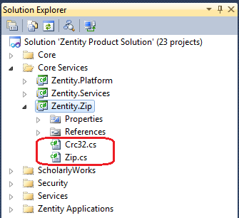

## Build the Zentity solution

1. Select the build configuration for which you would like to build.

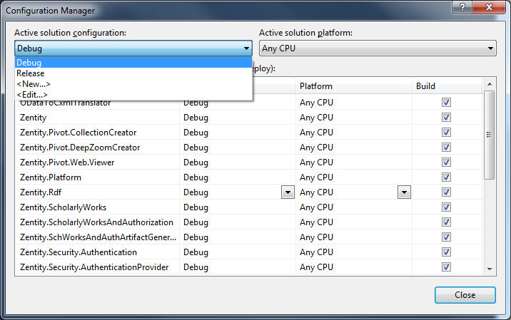

1. Build the solution “Zentity Product Solution” in Visual Studio.

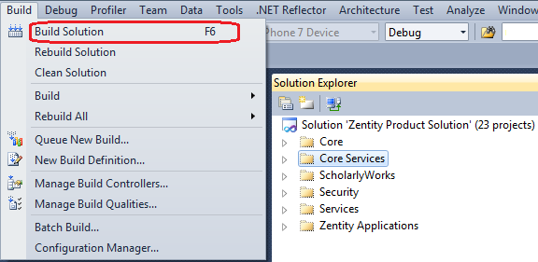

1. The solution should build without any errors.
   1. If you get any errors related to missing assembly references, then please verify and correct the assembly reference paths.

## Build the Zentity installers (msi)

1. Once the complete “Zentity Product Solution” is successfully built, we can then build the installers. The following are the two installer projects in Zentity :
   1. Zentity.Installer.Client
   2. Zentity.Installer.Server
2. In order the build the installer projects we need to place the built assemblies and other artifacts in a particular folder structure. To assist this there is a batch file (CreateInstallationFolders.bat) that is provided in the source code tree under “[ZentitySourceLocation]/Zentity_Main/”
3. Open a command prompt window and navigate to the Zentity_Main folder.

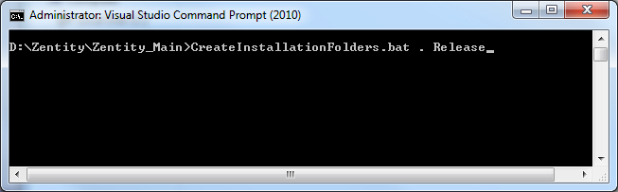

1. Execute the batch file “CreateInstallationFolders.bat”. This takes two arguments
   1. The location where to create the installation folders
   2. The build configuration from which assemblies will be copied – Release, Debug

e.g. – CreateInstallationFolders.bat . Release

1. This will copy the required assemblies and artifacts into a folder named “Build_Target”.
2. Before opening the WIX installer projects ensure that you have installed the Wix Toolkit 3.5.
3. Open the “Zentity.Installer.Client” solution and build it. The “Zentity.Installer.Client.msi” installer file will be located in the “bin” folder of the project.
4. Open the “Zentity.Installer.Server” solution and build it. The “Zentity.Installer.Server.msi” installer file will be located in the “bin” folder of the project.